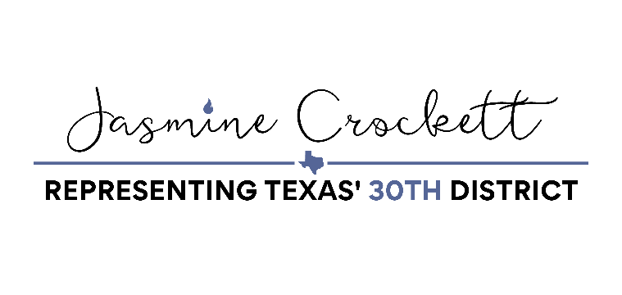
Heirs’ Property Relending Program Progress Act One Pager
Endorsements: Rural Coalition, Land Loss Prevention Project, Federation of Southern Cooperatives
BACKGROUND
Heirs’ property is created when a landowner dies without a will or estate planning strategy delegating the transfer of land ownership. The 2018 Farm Bill authorized the creation of the Heirs’ Property Relending Program (HPRP) to mitigate the legal complications caused for producers by heirs’ property. HPRP provides loan funds to intermediaries who will re-lend funds to individuals or entities with undivided ownership interests to resolve ownership and succession issues relating to heirs’ property. In short, the goal of this relending program is to provide producers access to capital to mitigate heirs’ property issues. USDA’s Farm Service Agency (FSA) has determined that HPRP loan funds can be used:
- To buy out fractional interests held in tenancy in common by other heirs in jointly owned property
- To pay for costs associated with developing and implementing a succession plan (such as closing costs, appraisals, title searches, surveys, preparing documents, mediation, and legal services)

HPRP loans cannot be used for the purpose of land development, acquisition of personal property, repair of buildings, payment of operating costs, payment of finders’ fees, etc. As soon as FSA selects lenders, heirs are able to apply directly to those lenders for loans and assistance. Heirs may use the loans to resolve title issues by financing the purchase or consolidation of property interests and financing costs associate with a succession plan.

CRITICAL ISSUES
1. PAYMENTS: USDA explained that the approved three approved CDFIs have received a combined $12 million dollars, but are facing difficulty getting the money to producers. This is because they cannot use the funds to cover administrative costs, only being allowed to loan them out and recoup costs through collecting interest. The CDFIs receive the funds as a 1% loan from USDA. CDFIs have found that they are unable to pay back the loan and cover administrative costs without charging such high interest rates to the producers that no one would use the program. As a result, not a single dollar has actually been loaned to a producer.

2. INSUFFICIENT COVERAGE: USDA announced that Akiptan Inc., the Cherokee Nation Economic Development Trust Authority (CNEDTA), and the Shared Capital Cooperative have been approved or conditionally approved as Community Development Financial Institutions (CDFIs) which can act as intermediary lenders through HPRP. However, the stipulations associated with these CDFI’s are numerous. Akiptan Inc. requires that loans and technical assistance go towards those engaged in Native agriculture, CNEDTA targets producers in rural areas within the Cherokee Nation Reservation, and Shared Capital Cooperative only covers producers in the states of Alabama, Florida, Georgia, Louisiana, Mississippi, and South Carolina only. These CDFIs were approved in 2022, and USDA confirmed there are no additional applications in the pipeline. As a result, the majority of black producers are not eligible to apply for HPRP funds.

3. FUTURE FUNDS: USDA confirmed that until new funding levels are approved, they have $61 million dollars available to lend to CDFIs. But in the FY25 President's Budget Request, that will be reduced to $7.7 million dollars. Failing to get this funding out the door has already jeopardized over $50 million dollars, and could result in the complete failure of the program.

SOLUTIONS
At USDA’s suggestion, allowing for CDFIs to use some of the funds initially intended as loans to cover administrative costs outright, rather than relying on high interest payments down the line, will allow the money to actually get out the door to ultimate borrowers. This also addresses the problem of CDFIs not being interested in applying to be in the program. More producers will be covered if more CDFIs join the program. Because the amount of the loan is capped at $5 million dollars in current regulation, up to 30% covering administrative costs should alleviate the fundamental issue keeping the program stalled.

